From: <https://strategic-culture.org/news/2022/06/02/why-is-it-so-hard-finnish-nazism-nato-growing-suicide-pact-threatens-to-light-the-world-on-fire/>

Author: Matthew Ehret

Date: June 2, 2022

***Is it possible that the war we thought we won in 1945 was merely a battle within a larger war for civilization whose outcome yet remains to be seen?***

The decision recently expressed by the Finnish and Swedish governments to join NATO’s collective suicide pact shouldn’t come as a huge surprise to anyone who has been paying attention to the growth of Nazism over the past 77 years.

Not only is this growth taking the form of a renewal of [swastika-tattooed, black sun of the occult loving, wolfsangel-wearing Azov, C14, Svoboda and Aidar neo-Nazis in Ukraine today](https://canadianpatriot.org/2022/04/28/how-ukraines-jewish-president-zelensky-made-peace-with-neo-nazi-paramilitaries-on-front-lines-of-war-with-russia/), but a whole re-writing of WWII history which has taken an accelerated dive into unreality during the 30 years since the Soviet Union collapsed.

Across the spectrum of post Warsaw Pact members absorbed into NATO such as Lithuania, Estonia, Albania, Slovakia, and Latvia, Nazi collaborators of WWII have been glorified with statues, public plaques, monuments, and even schools, parks and streets named after Nazis. Celebrating Nazi collaborators while tearing down pro-Soviet monuments has nearly become a pre-condition for any nation wishing to join NATO.

In Estonia, which joined NATO in 2004, the defense ministry-funded Erna Society has celebrated the Nazi Erna Saboteur group that worked with the Waffen SS in WWII with the [Erna advance Guard being](https://www.rt.com/news/estonia-military-nazi-erna-607/) raised to official national heroes. In Albania, Prime Minister Edi Rama rehabilitated Nazi collaborator [Midhat Frasheri](http://dengalnaserben.weebly.com/history-1900-to-1949/1944-kosovo-ciami6-giving-birth-to-klauck" \t "_blank), who deported thousands of Kosovo Jews to death camps.

In Lithuania, the pro-Nazi Lithuanian Activist Front leader Juozas Lukša who carried out atrocities in Kaunas was honored as a national hero by an act of Parliament [which passed a resolution](https://www.jpost.com/judaism/lithuanian-lawmakers-honor-an-alleged-perpetrator-of-holocaust-pogrom-633266) dubbing “the year 2021 as the year of Juozas Luksa-Daumantas”. [In Slovakia](https://www.strategic-culture.org/news/2022/06/01/new-generation-of-us-trained-extremists-fighting-russia-are-we-prepared-for-blowback/), the ‘Our Slovakia Peoples Party’ led by neo-Nazi Marián Kotleba moved from the fringe to mainstream wining 10% of parliamentary seats in 2019.

**Nazi Skeletons in Finland and Sweden’s Closets**

While Finland likes to celebrate the fact that their 1941-1944 war with Russia had nothing to do with WWII, but was simply a defensive alliance with Germany against the evil Soviet Union, and while Sweden likes to celebrate the fact that it remained neutral during WWII, the facts tell a very different story.

Not only did both nations play aggressive roles in the war against the Soviet Union during [Operation Barbarossa](https://en.wikipedia.org/wiki/Operation_Barbarossa#Battle_of_Moscow) and beyond, but both nations also provided vast loans and other economic support from 1940 until 1945.

On a purely military level, “neutral” Sweden led by [King Gustav V](https://www.independent.co.uk/news/world/europe/swedish-royal-family-hit-by-fresh-nazi-allegations-2148787.html) and Social Democrat Prime Minister Per Albin Hannson ensured that their territories were made available to the Nazis [during the Battle of Narvik in 1940](https://www.dailymail.co.uk/news/article-2154901/Neutral-Sweden-allowed-Nazis-use-railways-occupy-Norway--transfer-Jews-death-camps-new-book-claims.html) that resulted in the fall of Norway. When Operation Barbarossa was launched a year later, Germany was [permitted to use Swedish territory](http://www.historyisnowmagazine.com/blog/2017/12/18/was-sweden-really-neutral-in-world-war-two#.YofP5OjMJD8=), rail and communication networks to invade the Soviet Union via Finland. German soldiers and battle equipment were carried from Oslo to Haparanda in Northern Sweden in preparation for assaults on Russia.

On the economic front, 37% of Swedish exports throughout the war went to Germany which included 10 million tons of iron ore per year, as well as the largest production of ball bearings vital for the Nazi war machine which were exported via harbors in Nazi-occupied Norway. The pro-fascist von Rosen family played one of the most instrumental roles in promoting Nazi ideology in Sweden [with Eric von Rosen](https://www.strategic-culture.org/news/2022/06/01/the-big-questions-we-should-all-be-asking-geopolitically/) co-founding the National Socialist Party of Sweden and providing access to the upper crust of Swedish nobility to the German high command during the 1920s-1930s.

Additionally, Count [Hugo von Rosen](https://tonyseed.wordpress.com/2010/12/30/electroluxs-nazi-connections/amp/) acted as director of the U.S. branch of the Swedish Enskilda Bank and SKF Bearing which managed the flow of funds and ball bearings (made in Philadelphia) to the Wehrmacht throughout the war.

Historian Douglas Macdonald [wrote](https://tonyseed.wordpress.com/2010/12/30/electroluxs-nazi-connections/amp/): *“SKF’s ball bearings were absolutely essential to the Nazis. The Luftwaffe could not fly without ball bearings, and tanks and armored cars could not roll without them. Nazi guns, bombsights, generators and engines, ventilating systems, U-boats, railroads, mining machinery and communications devices could not work without ball bearings. In fact, the Nazis could not have fought the Second World War if Wallenberg’s SKF had not supplied them with all the ball bearings that they needed”.*

Hugo was Goering’s second cousin by marriage and his cousin Eric will play an important role in this story shortly.

**Finland’s Nazi Heritage Reviewed**

Unlike Sweden, Finland never tried to feign neutrality, and in that sense can at least be applauded for avoiding the hypocrisy of their Swedish cousins. Sharing a 1340 km border with Russia which includes an area within 40 km of striking distance from today’s St Petersburg, Finland was a high value piece of real estate for the Nazis.

During the war, 8000 Finnish soldiers fought directly alongside the Nazis against the Russians, with many serving in Nazi SS Panzer divisions between 1941-1943. [A scandalous 248 page report](https://nationalpost.com/news/israeli-historian-lauds-finland-for-report-on-wwii-killings) published by the Finnish government in 2019 revealed that no less than 1408 Finnish volunteers served directly in SS Panzer division carrying out mass atrocities including the extermination of Jews and other war crimes.

The cause of Finland’s alliance with the Nazis during the war is also much darker than sanitized history books let on.

Soviet leaders had been watching the buildup of the Nazi war machine heading towards Russia like a slow-motion train collision from the moment the [1938 Munich Agreement](https://risingtidefoundation.net/2022/05/16/the-shocking-truth-of-the-1938-munich-agreement/) was reached that saw the destruction of Czechoslovakia and the growth of a Frankenstein Monster in the heart of Europe.

In his brilliant [‘The Shocking Truth About the 1938 Munich Agreement’](https://thenakedhedgie.com/2021/12/17/appeasement-the-shocking-truth-about-the-1938-munich-agreement-part-1-of-3/), Alex Krainer demonstrates that British secret diplomacy ensured that from Hitler’s takeover of Austria to the invasion of Poland in September 1939, Britain’s appeasement policy merely feigned opposition to Nazism while actually facilitating its unrelenting growth as a Frankenstein monster in the heart of Europe.

**The Race to Secure the Heartland and Finland’s Nazi Turn**

Knowing that an assault was inevitable, Russia signed the [Molotov-Ribbentrop Pact](https://www.jpost.com/international/on-this-day-the-molotov-ribbentrop-pact-and-the-battle-of-stalingrad-677473) in August 1939 to bide time while attempting to establish a buffer zone between the expansionist Nazi regime and herself.

During this small window, a race was on to consolidate spheres of interest with Russia acting defensively to secure her soft underbelly before the inevitable hot war was launched. Germany meanwhile raced to bring on the heat with military operations that spread the Reich across Europe.

Russia won several important strategic diplomatic victories by signing mutual assistance pacts with Latvia, Lithuania and Estonia. However, Finland, under the control of Field Marshal Carl Gustaf Mannerheim and Prime Minister Risto Ryti rejected Russia’s offer.

In the aborted Russia-Finnish Mutual Security Treaty, Russia offered to cede South Karelia in the north in exchange for the Soviet border moving westward on the Karelian Isthmus and permission to station Russian bases in Finland. The pro-German government of Ryti and Mannerheim had publicly been cozying up to the Germans during the 1930s and much of Finland’s aristocracy had entertained delusional visions of expansionism along with their Swedish pro-Nazi counterparts believing that a major part of northwestern Russia called East Karelia apparently contained a “pure” Nordic people untainted by both Slavic and Scandinavian blood.

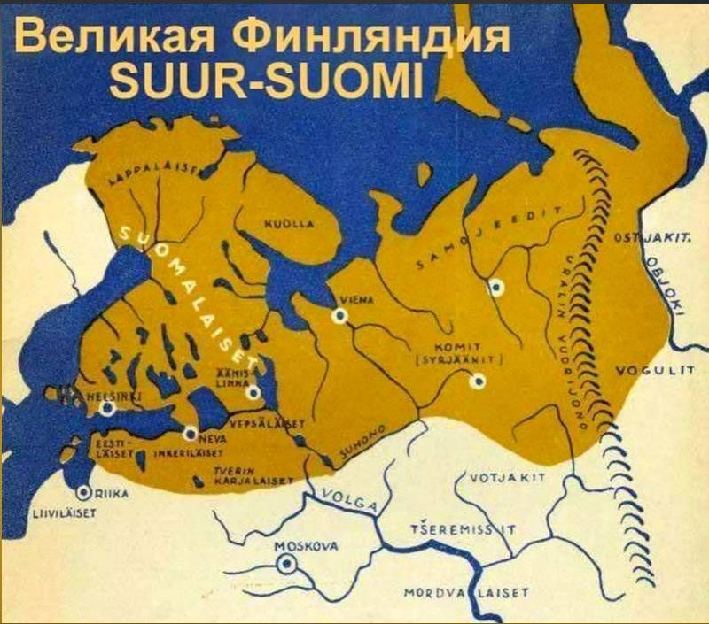  
Caption: A World War 2 era map showcasing the most radical version of ‘Greater Finland’ ideology that saw much of North Russian territory rightfully belonging to Finland

Finland’s rejection of the cooperation agreement resulted in Russia’s November 1939 decision to invade resulting in the loss of 20,000 Finnish soldiers, 11% of her territory representing 1/3 of her economic potential and a burnt ego. This four month “Winter War” ended by March 1940 with a reduced and humiliated Finland aching for revenge.

Field Marshall Mannerheim and PM Ryti were devout believers in the ‘greater Finland’ myth with Mannerheim proclaiming loudly to his soldiers on the eve of Finland’s agreement to join hands with the Nazis that *“in 1918 during the war of liberation [against Russia], I stated to the Finnish and Vienna Karelians that I would not set my sword in my scabbard before Finland and East Karelia would be free”.* This speech made it difficult to maintain the notion that Finland’s alliance with the Nazis was simply ‘defensive’.

Although it is commonly claimed by revisionist historians that Herman Goring sent a personal messenger to Helsinki asking for permission to use Finland’s territory in exchange for weapons and support in August 1940, the 1945 deposition of SS Colonel Horst Kitschmann – who was privy to these exchanges, testified that it was [Finnish] Mannerheim himself who was the first to contact Goring suggesting this arrangement be made.

Documented in Henrik Lunde’s [‘Finland’s War of Choice’](http://maxima-library.org/knigi/knigi/b/360844?format=read) Kitschmann testified: *“In the course of these conversations von Albedill [German major on the attaché staff who briefed Kitschmann] told me [(Lunde)] that as early as September, 1940, Major General Roessing, acting on an order of Hitler and of the German General Staff, had arranged the visit of Major General Talwel, the Plenipotentiary of Marshal Mannerheim, to the Führer’s headquarters in Berlin. During this visit an agreement was reached between the German and Finnish General Staffs for joint preparations for a war of aggression, and its execution, against the Soviet Union. In this connection General Talwel told me [(Lunde)], during a conference at his staff headquarters in Aunosa in November, 1941, that he [(Talwel)], acting on Marshal Mannerheim’s personal orders, had as far back as September, 1940—been one of the first [Finns] to contact the German High Command with a view to joint preparation for a German and Finnish attack on the Soviet Union.”*

In September 1940, a [secret Finnish-German transit treaty](https://en.wikipedia.org/wiki/Transit_of_German_troops_through_Finland_and_Sweden#:~:text=German%20troop%20transfers%20through%20Finland,-In%20the%20summer&text=The%20negotiations%20were%20carried%20out,of%20Vaasa%20on%2021%20September.) was approved and the trainwreck that was Barbarossa was put into motion.

On June 16, 1941 Mannerheim called upon 16% of the Finnish population to fight alongside the Wehrmacht in preparation for this onslaught.

When Barbarossa was officially launched on June 22, 1941, there were 400,000 Finnish and German troops in Finland, as Finnish airfields were given over to Nazi bombers. Mannerheim’s pact with the devil resulted in early wins as his dream of a “Greater Finland” had finally come alive with vast territories from Murmansk to Lake Onegia [falling to Finnish occupation throughout 1941-1944](https://www.cambridge.org/core/books/abs/searching-for-a-principle-of-humanity-in-international-humanitarian-law/military-occupation-of-eastern-karelia-by-finland-in-19411944/41A8DC3037E169ACDF98D733875E2525). During this time ethnic Russians and Jews in Finland were sent to forced labor camps where many were exterminated.

[The 2019 Finnish report](https://nationalpost.com/news/israeli-historian-lauds-finland-for-report-on-wwii-killings) stated: *“The subunits and men of SS division Wiking engaged during the march into the Soviet Union and the drive through Ukraine and the Caucasus were involved in numerous atrocities… The diaries and recollections by the Finnish volunteers show that practically everyone among them must, from the very beginning have been aware of the atrocities and massacres”.*

As the Finnish SS Wiking Division advanced via west Ukraine between July-August 1941, over 10,000 civilians were killed in Lviv and Zhytomyr and over 600,000 more were killed in the region from the start of Barbarossa until March 1942.

**The Strange Case of Finland’s Enduring Swastika**

A word must now be said about Finland’s peculiar official air force logo created in 1919, and which lasted until 2020 when the logo was retired from planes, flags and uniforms (although still maintained on the walls of the air force academy).

Here, I am referring of course to the strange swastika that a post-1945 Finland did not think wise to remove from its military planes or uniforms despite the downfall of their Nazi allies.

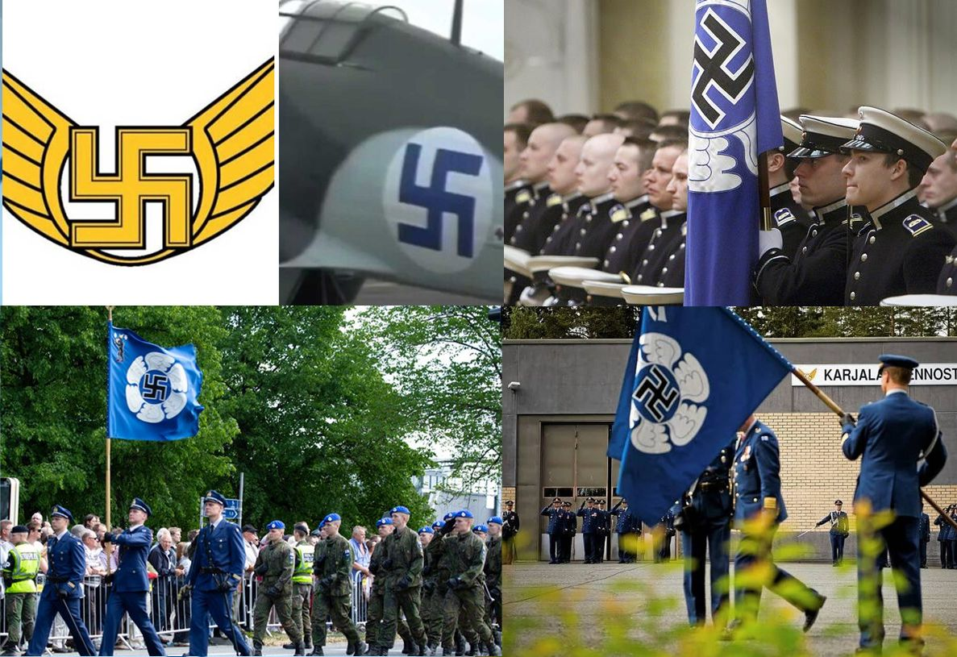

Sanitized history books are quick to dispel this anomalous century-long fetish with the swastika as a total coincidence having nothing to do with the Nazis due to the fact that the Nazi party adopted the symbol a full year after the Finnish government. However, as most of our official historical narratives, this one also crumbles to pieces upon the slightest application of pressure.

As the story goes, Sweden’s Count Eric von Rosen of Sweden bequeathed to Finland’s White Army the gift of a Thulin Type D aircraft decorated with swastikas in 1918 which established the Finnish air force with the swastika becoming its official logo. Since von Rosen had already been using the swastika as his personal emblem since first seeing it on ancient runes while in high school, it is concluded that the Finnish military swastikas and their Nazi counterparts could have no connection what-so-ever.

This claim completely ignores the fact that both von Rosen brothers Eric and Clarence were leading nobles who

1. proudly championed the Nazi cause,
2. sponsored Swedish eugenics via the Swedish Institute of Racial biology at Uppsala University (c. 1922),
3. lobbied for sterilization laws, and
4. introduced Hitler to the upper crust of Sweden’s elite.

In 1933, Eric von Rosen became a founding member of the Nationalsocialistiska Blocket (aka: “The National Socialist Party of Sweden”).

The vigorous support for the Nazis (which included the von Rosen’s influence over Sweden’s Enskilda Bank and SKF) also changes how we must interpret the close relationship which both Clarence, Eric and Hugo von Rosen enjoyed with their brother-in-law Hermann Goring who [Herman Goering] had worked as personal pilot for Eric von Rosen after WWI.

It was during an extended stay at von Rosen’s Rockelstad Castle in 1920 that **Goring was first introduced** to   
1) von Rosen’s swastikas which decorated the castle and adjacent hunting lodge,   
2) von Rosen’s passion for nature conservation which Goring shared, later becoming the first Nazi Reich minister of forestry and conservationism in the 1930s and   
3) Eric von Rosen’s sister-in-law Carin von Kantzow who soon became Goring’s wife [and dubbed by Hitler](https://www.thelocal.se/20111006/36538/) “First Lady of the Nazi Party”.

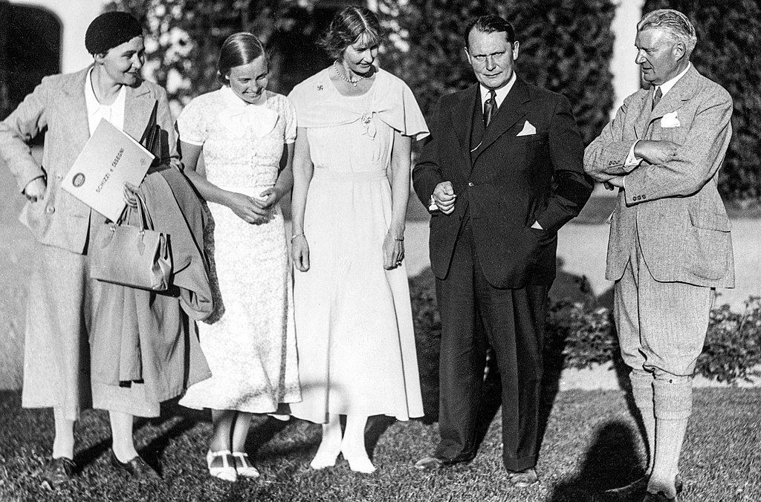

*Caption; Picture of Birgitta, Mary, Hermann Göring and Eric von Rosen at Rockelstad in Sweden 1933*

Eric and Clarence von Rosen had been followers of [an occult sect called Ariosophism](https://ordoabchao.ca/volume-three/ariosophy), led by a mystic rune-obsessed poet named Guido von List who simply took Madame Blavatsky’s theosophy and infused an Aryan racial superiority twist with a heightened focus on Wotan myths. In this sect, the swastika and other rune symbols like the

* [Othala rune](https://en.wikipedia.org/wiki/Othala),
* [Ehlaz/life rune](https://www.adl.org/education/references/hate-symbols/life-rune)[[1]](#endnote-1),
* [Sig rune](https://www.google.com/search?q=%E2%80%A2%09Sig+rune&newwindow=1&hl=en&tbm=isch&sxsrf=ALiCzsbmM3uTVE5wkRFbZIeezgc3QJVbsg%3A1662420127577&source=hp&biw=1718&bih=667&ei=n4QWY-aAIfeh5NoP2OGNuAs&iflsig=AJiK0e8AAAAAYxaSr8XmTFMPvK8D7oEwgW7uJmMoJWu4&ved=0ahUKEwimzK3J5f75AhX3EFkFHdhwA7cQ4dUDCAc&uact=5&oq=%E2%80%A2%09Sig+rune&gs_lcp=CgNpbWcQAzoHCCMQ6gIQJ1CtClj0JmD1MWgBcAB4AIABRogBugGSAQEzmAEAoAECoAEBqgELZ3dzLXdpei1pbWewAQo&sclient=img) (later used by SS), and
* [wolfsangel](https://en.wikipedia.org/wiki/Wolfsangel)

were treated as sacred images endowed with magic power.

Guido von List had organized his sect into an inner and outer core with the “elect” learning a secret interpretation of the runes under an elite occult society called the High Armanen Order where von List himself served as Grand Master.

This racist occult Aryanism with its Theosophical aim to infuse Hindu and Buddhist mysticism into a new post-Christian age became an extremely popular phenomenon among the noble families of Europe during this period. The aim was to use a perverse interpretation of eastern spiritualism devoid of substance and create a new order premised on an **“Age of Aquarius”** which would supersede the obsolete **“Age of Pisces”** that represented the obsolete of reason exemplified by the likes of Socrates, Plato and Christ.

Out of the High Armanen Order soon grew another secret occult organization called [the Thule Society](https://www.crystalinks.com/thule.html) which saw

* Rudolf Hess,
* Hans Frank,
* Hermann Goring,
* Karl Haushofer and
* Hitler’s coach Dietrich Eckart

as leading members.

**An Uncomfortable Fact Must Now be Confronted**

It is an uncomfortable fact of history that those same powers that gave rise to fascism [were never punished at the Nuremburg Trials](https://www.strategic-culture.org/news/2022/06/01/the-big-questions-we-should-all-be-asking-geopolitically/). Those Wall Street industrialists and financiers that supplied Germany with funding and supplies before and during the war **were** punished.

… nor were the [British financiers at the Bank of England who ensured](https://www.strategic-culture.org/news/2022/05/31/problem-with-two-speed-eu-plan-its-going-in-wrong-direction/) that Nazi coffers would be replete with confiscated loot from Austria, Czechoslovakia or Poland.

The post-war age not only saw a vast re-organization of fascist killers in the form of the [CIA/NATO managed Operation Gladio](https://cynthiachung.substack.com/p/operation-gladio-how-nato-conducted?s=r) and we know that Allan Dulles directly oversaw the [re-activation of Hitler’s intelligence chief Reinhard Gehlen](https://allthatsinteresting.com/reinhard-gehlen) into the command structure of West German Intelligence along with his entire network. Ukrainian Nazis like [Stefan Bandera and Mikola Lebed](https://www.sott.net/article/276880-Allen-Dulles-and-the-Ukrainian-fascists-Did-the-CIA-MI6-use-of-Nazis-in-Ukraine-during-the-Cold-War-ever-stop) were promptly absorbed into this same apparatus with Bandera working with Gehlen from 1956 to his death in 1958 while Lebed was absorbed into American intelligence running a CIA front organization called Prolog.

As Cynthia Chung recently outlined in her [Sleepwalking into Fascism](https://www.strategic-culture.org/news/2022/06/01/the-big-questions-we-should-all-be-asking-geopolitically/) that no less than ten high level former Nazis enjoyed vast power within NATO’s command structure during the dark years of Operation Gladio. Cynthia writes: *“From 1957 to 1983, NATO had at least one if not several high ranking “former” Nazis in full command of multiple departments within NATO… The position of NATO Commander and Chief of Allied Forces Central Europe (CINCENT Commander in Chief, Allied Forces Central Europe – AFCENT) was a position that was filled SOLELY by “former” Nazis for 16 YEARS STRAIGHT, from 1967-1983.”*

During these years, not only did Gladio ‘stay behinds’ arrange a stream of terrorism against the general population of Europe using nominally ‘Marxist’ front groups or [carrying out hits of high value targets](https://www.youtube.com/watch?v=SFzBvavbUXg) like Dag Hammarskjold, Enrico Mattei, Aldo Moro or Alfred Herrhausen when needed. Statesmen who did not play by the rules of the Great Game were sadly not long for this world.

NATO’s self-professed image as a harbinger of the ‘liberal rules based international order’ is more than a little superficial when considering the Nazi-riddled alliances which many NATO-philes at the Atlantic Council may wish be forgotten. This history also should cause us to re-evaluate the true causes for the [1949 creation of NATO in](https://matthewehret.substack.com/p/the-age-of-chatham-house-and-the?s=w) the first place which served as a nail in the coffin for Franklin Roosevelt’s vision of a [U.S.-Russia-China alliance](https://canadianpatriot.org/2022/04/21/the-post-war-us-china-alliance-that-nearly-was/) which he hoped would shape the post-WW2 age.

NATO’s growth around Russia’s perimeter since 1998, and the NATO-led mass atrocities of bombings in Bosnia, Afghanistan, and Libya should also be re-evaluated with this Nazi pedigree in mind.

Why did NATO post images of a Ukrainian soldier clearly brandishing a Thule-society [black sun of the occult](https://twitter.com/rupasubramanya/status/1501612825969664001?lang=en) on her uniform in honor of ‘Women’s’ Day’ this year?

Why are active Ukrainian Nazis serving in Azov, and Aidar battalions systemically glossed over by NATO propaganda outlets or mainstream media despite the proven cases of mass atrocities in East Donbass since 2014?

Why are Nazi movements seeing a vast revival across East European space- especially within countries that have come under the influence of NATO since the Soviet Union’s collapse?

Is it possible that the war we thought the allies won in 1945 was merely a battle within a larger war for civilization whose outcome yet remains to be seen? Certainly patriots of Finland and Sweden should think very deeply about the dark traditions which risk being revived as they join into **a new** [**Operation Barbarossa**](https://en.wikipedia.org/wiki/Operation_Barbarossa#Battle_of_Moscow) **in the 21st century**.

The author recently delivered a presentation on this topic [which can be viewed here.](https://canadianpatriot.org/2022/05/19/the-great-game-this-week-nazi-skeletons-in-finlands-closet/)

1. Nazi Germany appropriated many pre-Roman European symbols, such as runic symbols, in an attempt to glorify an idealized "Aryan/Norse" heritage. One of these was the so-called "life rune" (from the German Lebensrune), also known as the Elhaz or Algis rune. Elhaz means "elk" and in early Europe this symbol had meanings related to stags or hunting, as well as honor, nobility, or protection. The Nazis used the symbol in various contexts, including the SS's Lebensborn project. [↑](#endnote-ref-1)